- Internship Name : Data Analysis
- Task Name: Task 1: Python Setup, Jupyter Notebook, Variables, Data Types, and Operators
- Your Name : Shubhangi Naresh Khonde
- Internship Organization :
- Date:

1. Objective
The objective of this task was to set up a Python development environment and practice the basic concepts of Python programming: variables, data types, arithmetic operators, and comparison operators.

2. Tools Used
- Python 3.13.2: the programming language
- Visual Studio Code (VS Code): the code editor
- Jupyter Notebook (.ipynb): an interactive environment, run inside VS Code using the Python and Jupyter extensions

3. Environment Setup
- Installed Python on the system.
- Installed Visual Studio Code.
- Installed the Python and Jupyter extensions in VS Code.
- Selected the Python 3.13.2 kernel and installed ipykernel.
- Created two files, Task1.py and Task1.ipynb.
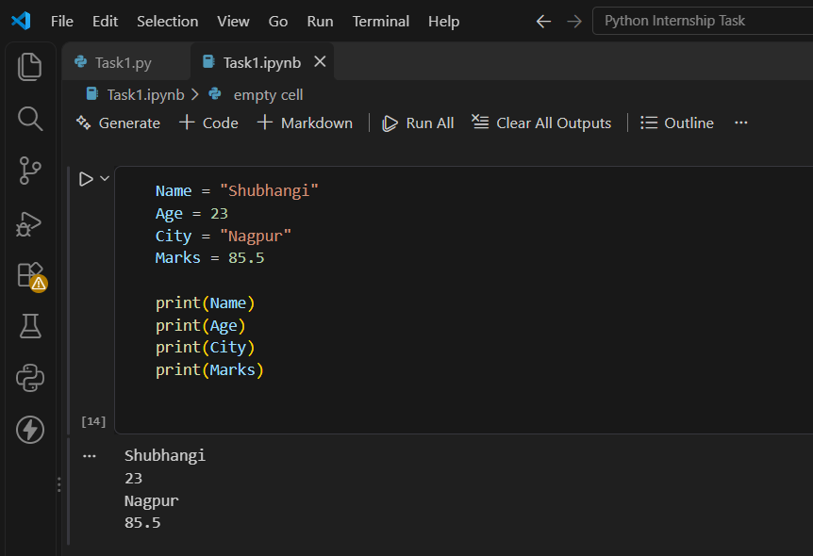

4. Variables
A variable is a named location used to store data in memory. Python does not need the data type to be declared, because it is detected automatically.
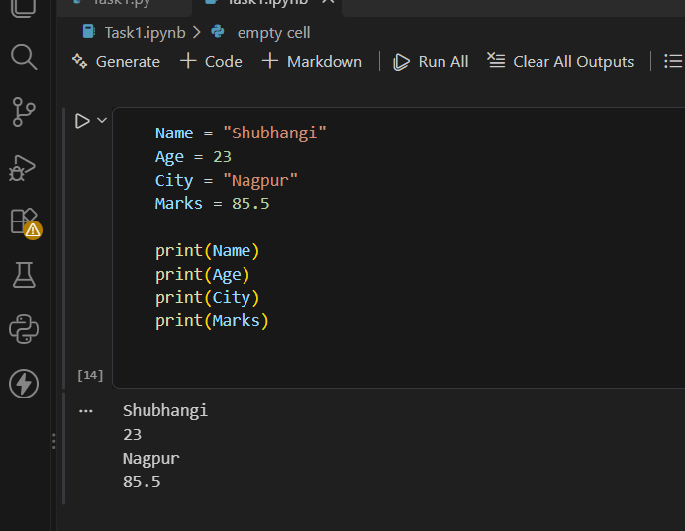

5. Data Types
Python has several built-in data types. The type() function is used to check the type of a value.
Data Type | Example | Description
str | "Shubhangi" | Text
int | 23 | Whole number
float | 85.5 | Decimal number
bool | True | True or False value

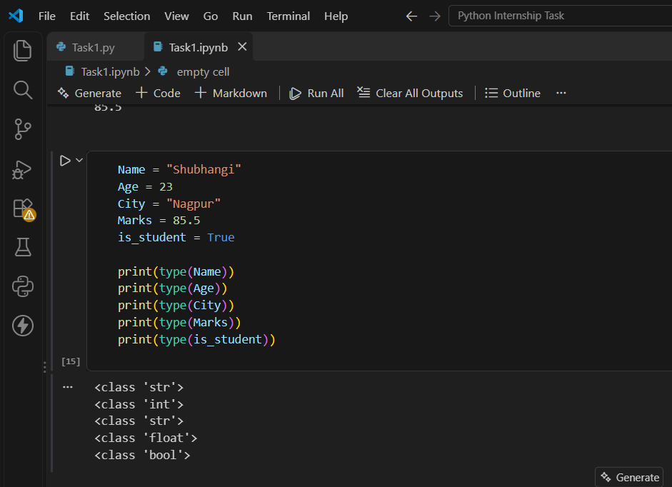
6. Arithmetic Operators
Arithmetic operators perform mathematical calculations. Here A = 10 and B = 3.
Operator | Operation | Result
+ | Addition | 13
- | Subtraction | 7
* | Multiplication | 30
/ | Division | 3.3333333333333335
% | Modulus (remainder) | 1
// | Floor division | 3
** | Power | 1000
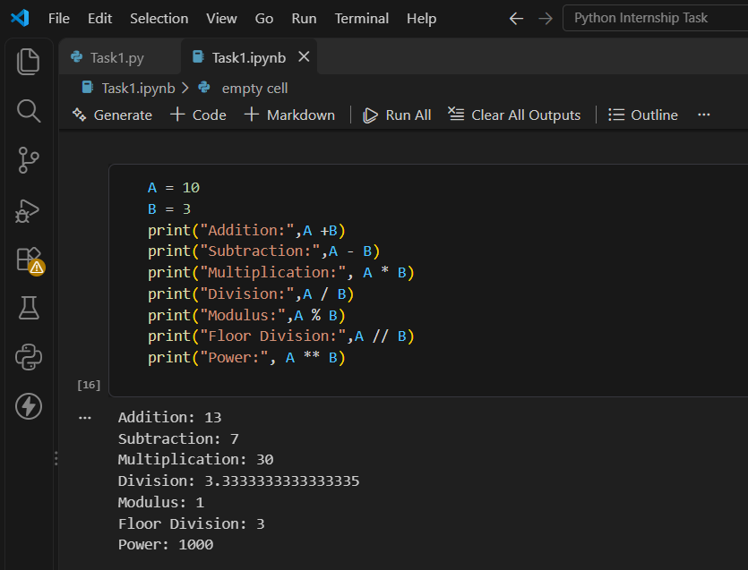

7. Comparison Operators
Comparison operators compare two values and always return a Boolean result (True or False). Here X = 10 and Y = 20.
Expression | Meaning | Result
X == Y | Equal to | False
X != Y | Not equal to | True
X > Y | Greater than | False
X < Y | Less than | True
X >= Y | Greater than or equal to | False
X <= Y | Less than or equal to | True
X >= 10 | Greater than or equal to 10 | True
X <= 5 | Less than or equal to 5 | False

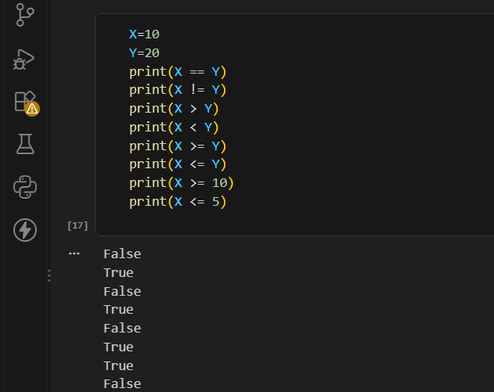

8. Conclusion
In this task, I successfully set up Python and Jupyter Notebook in VS Code and practiced variables, data types, arithmetic operators, and comparison operators. I learned how to store data in variables, check data types using type(), perform calculations, and compare values using operators. This task gave me a strong foundation for learning more advanced Python topics such as conditions, loops, and functions.

